Village of Caseyville RFP
Caseyville Village Hall/Community Center, 909 South Main Street, Caseyville Il 62232
Solar Energy Grant and Roof Mounted System – 5/7/2021

Project will consist of all necessary paperwork and documentation along with all materials and installation to provide an 86.4 kW (DC) Roof Mounted system. Contractor to verify before bidding. All solar panels to be installed on southward and/or westward facing side of building roof.
Provide follow equipment or equivalent:
(205) AC-440MH/144S (Axitec) solar panels
(110) Power optimizer modules (one every 2 panels)
(2) SE43.2KUS (SolarEdge) Inverters
(300) ECO foot panel support bases and mid supports
(110) 12’ rail system
(110) 12’ wind defectors
(35) Rail system splices
(Lot) Hardware and assembly material
(50) Grounding lugs and cable
(1) Connect main feeder in existing C/T cabinet
(1) Fused 400-amp main disconnect 3-pole raintight mounted next to meter/CT cab
(1) New RT 400-amp panel 120/208v – 3-phase – 4w with (2) 125A-3-pole circuit breakers
(600’) ¾” conduit for PV wire sleeves on roof
(7,000’) Furnish and install #10 PV wire as needed
(350) Furnish and install crimp type MC-4 connectors

Contractor to provide the following:
Web-based Monitoring
Engineering
Interconnection and SREC applications and documents
Disconnects and required signage per local code
Web monitoring system installed to customer provided internet connection within 10 ft. of inverters (web monitor next to inverters)
All conduits, wire and their associated supports, terminations, and testing (proposal is based on an EMT, IMC or FMC Conduit installation)
Shipping and insurance (full value of the order to the job site address)
Electrical Permits and inspections (other permits and inspections may be at an additional cost if required)
Trash and spoils removal
Upon completion the contractor will test and ensure system is working properly.
Contractor to follow all current state, federal building, NEC codes and standards as required.
Contractor will complete all design and submit all utility net metering and interconnection paperwork along SREC submittal paperwork. Invoices for interconnection fees will be paid by contractor.
Failure to obtain approval for the SREC’s grant program will constitute termination of contract at no cost to the Village of Caseyville.
For additional information on the solar please see website brochure.
https://www.illinoissfa.com/app/uploads/2019/05/ILSFA-brochure-non-profits-public-facilities.pdf

Warranty requirements:
• Panels – 15 Year Manufacturer’s Warranty (covers any material defects) and 25-year guarantee on 85% performance
• Inverters – 12-20 Years (12 included, can be upgraded for a small fee to 20 years)
• Optimizers – 25 Years
Installation labor work guaranteed for 1 year

A strict timeline must be followed for grant and additional documentation as required, see timeline below.

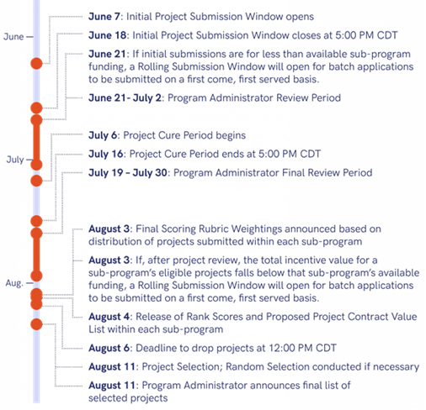

Village to provide as follows:
Village will provide dumpster and bin for all materials removed and disposal of all materials. Village will cut, remove, and disposal of any drywall as necessary. Village will patch, paint, and replace all drywall and ceiling tiles, as necessary.
Bid Requirements
Project labor agreement and prevailing wages will be required.
Contractor to provide all labor, material, equipment required and documentation to complete work as stated in this RFP. A 1-year labor/workmanship warranty must be provided on work performed. A site review visit is required before bids will be accepted. Please contact Joe Clark at 618-447-4720 for site inspection visit prior to bid. Contractor to verify all information.
Award will be made to the lowest, responsive, and responsible BIDDER. The Village of Caseyville reserves the right to reject any or all bids, to waive any informalities or technicalities in the bidding, and to determine which is the lowest, responsive, and most responsible bid for the work. The bids must be delivered to Caseyville Village Clerks Office or emailed to Brader@caseyville.org before 4:30 P.M., Tuesday, May 18th, 2021 during regular business hours. All work must be started upon approval of signed contract.

